**Experiment No:** 11  **Date:** 05/05/2021

**Aim:** Implementation of N-Queens problem

(Using Backtracking)

**Theory:**

**N- Queen Problem**

* N-Queens problem is one of the most common examples of backtracking.
* Our goal is to arrange N queens on an NxN chessboard such that no queen can strike down any other queen.
* A queen can attack horizontally, vertically, or diagonally.
* So, we start by placing the first queen anywhere arbitrarily and then place the next queen in any of the safe places.
* We continue this process until the number of unplaced queens becomes zero (a solution is found) or no safe place is left.
* If no safe place is left, then we change the position of the previously placed queen.

**Backtracking Algorithm**

* The idea is to place queens one by one in different columns, starting from the leftmost column.
* When we place a queen in a column, we check for clashes with already placed queens.
* In the current column, if we find a row for which there is no clash, we mark this row and column as part of the solution.
* If we do not find such a row due to clashes then we backtrack and return false.

**Algorithm Writing**

* Start in the leftmost column
* If all queens are placed

***return true***

* Try all rows in the current column.
* Do following for every tried row.
  + If the queen can be placed safely in this row then mark this [row, column] as part of the solution and recursively check if placing queen here leads to a solution.
  + If placing the queen in [row, column] leads to a solution then return true.
  + If placing queen doesn't lead to a solution then unmark this [row, column] (Backtrack) and go to step (a) to try other rows.
  + If all rows have been tried and nothing worked, return false to trigger backtracking.

**Algorithm**

Algorithm NQueens(k,n)

// Using backtracking, this procedre prints all

// possible placements of n queens on an n x n

//chessboard so that they are nonattacking

{

for i := 1 to n do

{

if Place(k,i)then

{

x[k] := i;

if (k=n) then write (x[1:n]);

else Nqueens(k + 1,n);

}

}

}

**Time Complexity**

* The isSafe method takes O(N) time as it iterates through our array every time.
* For each invocation of the placeQueen method, there is a loop which runs for O(N) time.
* In each iteration of this loop, there is isSafe invocation which is O(N) and a recursive call with a smaller argument.
* If we add all this up and define the run time as T(N).
* Then ***T(N) = O(N2) + N*T(N-1).***
* If you draw a recursion tree using this recurrence, the final term will be something like n3+ n!O(1).
* By the definition of Big O, this can be reduced to O(n!) running time.

**Program**

#include<iostream>

using namespace std;

int stepcount=0;

bool isSafe(int** arr, int x,int y,int n)

{

for(int row =0; row<x;row++)

{

stepcount++;

if(arr[row][y]==1)

{

stepcount++;

return false;

}

}

stepcount++;

int row =x;

stepcount++;

int col =y;

stepcount++;

while(row>=0 && col>=0)

{

stepcount++;

if(arr[row][col]==1)

{

stepcount++;

return false;

}

row--;

stepcount++;

col--;

stepcount++;

}

stepcount++;

row =x;

stepcount++;

col =y;

stepcount++;

while(row>=0 && col<n)

{

stepcount++;

if(arr[row][col]==1)

{

stepcount++;

return false;

}

row--;

stepcount++;

col++;

stepcount++;

}

return true;

}

bool nQueen(int** arr, int x, int n)

{

stepcount++;

if(x>=n)

{

stepcount++;

return true;

}

for(int col =0;col<n;col++)

{

stepcount++;

if(isSafe(arr,x,col,n))

{

arr[x][col] =1;

stepcount++;

stepcount++;

if(nQueen(arr,x+1,n))

{

stepcount++;

return true;

}

arr[x][col]=0;

stepcount++;

}

}

stepcount++;

return false;

}

int main()

{

int n;

cout<<"Enter the value of N: ";

cin>>n;

int** arr = new int*[n];

stepcount++;

for(int i=0;i<n;i++)

{

stepcount++;

arr[i]= new int [n]; for(int j=0;j<n;j++)

{

arr[i][j]=0;

stepcount++;

}

}

stepcount++;

if(nQueen(arr,0,n))

{

for(int i=0;i<n;i++)

{

stepcount++;

for(int j=0;j<n;j++)

{

stepcount++;

cout<<arr[i][j]<<" ";

}

cout<<endl;stepcount++;

}

}

cout<<"\n*******************"<<endl;

cout<<"Total Steps = "<<stepcount<<endl;

cout<<"*******************"<<endl;

}

**Output**

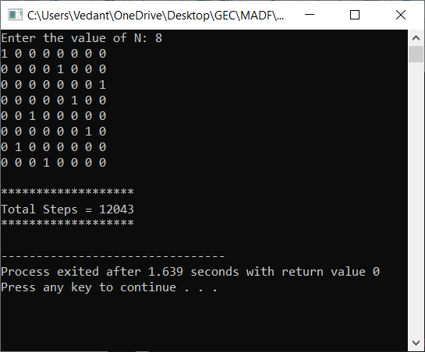

**Conclusion**

* Detailed concept of N-Queens problem (Using Backtracking)was studied successfully.
* Program using N-Queens Algorithm was executed successfully.
* The step count for the N-Queens Algorithm was obtained.